# Practical Project: Random Sentences Generator

This is an additional practical project, and **it is not mandatory and it is not included in the final score**. The main purpose is to use gained knowledge in different types of problems and to improve your portfolio and GitHub skills.

This **random sentence generator** is just for fun! These sentences can provide humor and be a cool way to surprise others by sharing a standout sentence on social media platforms and gathering your network's reaction.

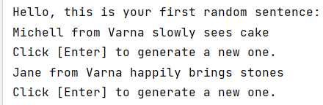

## Create GitHub Repository

Create a **new repository** from <https://github.com/new>. Choose a **meaningful name**, e. g. "RandomSentencesGeneratorByUsername", add a **short description,** and make your repo **public**. Also, **add a** README.md file and .gitignore **for Python**. Finally, **change the license** to "MIT and click on the [Create] **button** to **create your repository**.

|  |  |
| --- | --- |
|  | Please choose **your original and unique name** for your project!  Your GitHub profile should be **unique**.  You can follow this tutorial, but you can also **make changes** and **implement your project differently**. |

Now your **repository is created** and should look like this:

Now let's see how to **write the code** of our application.

## Write the Sentences Generator Code

Let's create the application and play with it.

### Create a PyCharm Project

First, we should **start PyCharm** and **create a new Python project**. Then, **choose an appropriate name** and a **place to save the project**.

Our project should be created and should look like this: 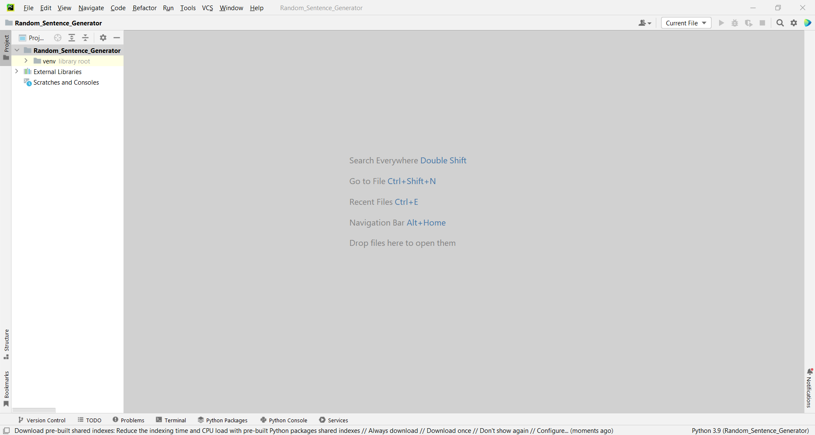

We should create a **new Python file** with the name of the game.

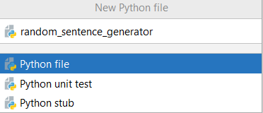

### Implement the Generator Logic

Now let's start working on our project.

#### Create the Sentence Model

To create our **sentences** we are going to need: **names**, **places**, **verbs**, **nouns**, **adverbs,** and **details**. The **sentence** that we will create is based on the following **model**:

* One sentence needs [Who from where] [Action] [Detail] to be created.
  + "Who from where" example: [Name + from + Place] ("David from London").
  + "Action" example: [Adverb] + [Verb] + [Noun] ("calmly watched the sunset").
  + "Detail" example: "near the river", "at home", "in the park".

#### Add Words for the Sentences

Let's start by creating **lists** with all the **words** we will use to create a **random** **sentence**. **Lists** are used to **store** **multiple** values in a **single** **variable**, instead of **declaring** **separate** **variables** for each **value**.

To **declare** a **list**, we use **square** **brackets or "list()"**.

Now let's create our first **list** and call it "names". To fill the **list** we will use **brackets**. Inside the **brackets**, write **names**, **separated** by a **comma**. These are some example names that you can use:

**"Peter", "Michell", "Jane", "Steve"**

Your list should look like this:



Now we need to create **lists** with words for "**places**", "**verbs**", "**nouns**", "**adverbs**" and "**details**". Do this by yourself. Here are some **words** you can use:

* **Places:**

|  |
| --- |
| "Sofia", "Plovdiv", "Varna", "Burgas" |

* **Verbs:**

|  |
| --- |
| "eats", "holds", "sees", "plays with", "brings" |

* **Nouns:**

|  |
| --- |
| "stones", "cake", "apple", "laptop", "bikes" |

* **Adverbs:**

|  |
| --- |
| "slowly", "diligently", "warmly", "sadly", "rapidly" |

* **Details:**

|  |
| --- |
| "near the river", "at home", "in the park" |

Finally, the lists should look like this:

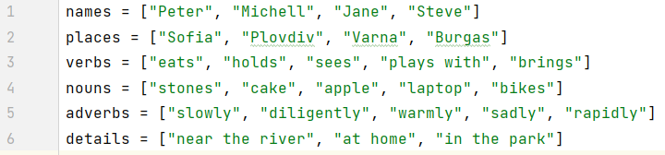

#### Create a Function for Getting a Random Word

Now we are going to create a **function**. Generally, **functions** are useful to **improve** code **reusability** by **reducing** code **duplication**. If we have the same **functionality** to perform in **multiple** **places**, then we can create one **function** with the required **functionality** and reuse it wherever it is **necessary** for the **application**. In our case, the **function** will help us choose **random** **words** every time.

To create a **function** you need the following things:

* First, the reserved word **"def"**.
* Second, we need a **name** for the **function**.
* Third, we should define **parameters** that the **function** will receive

Do it as follow:



Now let's write the function logic. First, we need to import the library **"random"**, then we will return the value from the method "**random.choice()**":

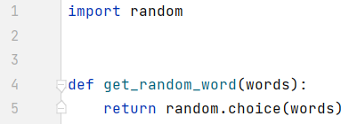

**Note: The "choice()" method returns a randomly selected element from the specified sequence.**

**More info:** [**https://www.w3schools.com/python/ref_random_choice.asp**](https://www.w3schools.com/python/ref_random_choice.asp)

It's time for the easy part – let's make the generator work.

First, we should create an endless while loop and create **variables** for all different **random** **words**. To do this we will use our **function** get_random_word(), which will do all the work for us.

Second, create a **variable** and name it "random_name". Make the **variable** keep the result from our get_random_word() function and **pass our** words **list** as an **argument** to the function. Do it as follow:



Now try to create **variables** for the other **words** yourself. They should all **pass the necessary lists** and **keep the results** from the get_random_word() **function**. Finally, it should look like this:

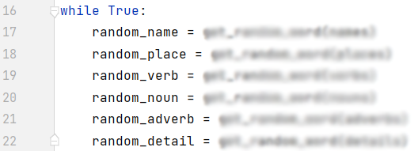

Next thing is to **construct** our **random** **sentence** and **print it** on the console. Remember the **model** that we are working on - we need "**Who from where**", then "**Action**" and last "**Details**":



Now what is left is to **write** the **sentence** on the **console**. Next, write a **message** to the user to press [Enter] to **generate** a new **sentence** and **read** his **input**. You know how to do that: You can also **write** a **greeting** **message** before the while loop: 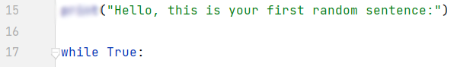

This is all it takes to **finish** our **project**, after you run it, the generator should look like this:

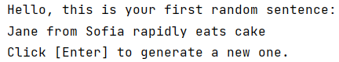



Now let's upload it to GitHub.

## Upload Your Project to Github

We already know how to clone our repository by using **Git** **Bash** or **GitHub Desktop**.

### Use GitBash (Option 1)

Go to the desired **directory**, right-click on a blank space **anywhere** in the folder, and select "**Git Bash Here**" to open the Git command line console. If the "**Git Bash Here**" menu is missing, you should first install Git.

Type the **"**gitclone**"** command followed by the link to your **repository**:

gitclone

This command is for cloning with **Git Bash**, paste your **repository** **URL** after the command.

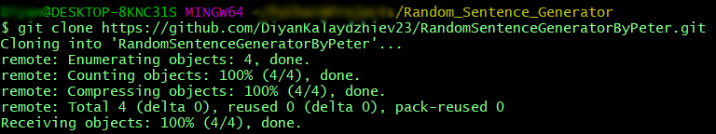

Your files from your GitHub repo will be downloaded to a **sub-folder** called as your project in GitHub, "**RandomSentencesGeneratorByPeter**" in our case.

The next thing to do is to add your project files to your cloned repository folder. It should look like this:

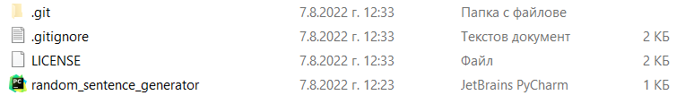

Now we are ready to upload our changes from "**Git Bash clone**". Go to the desired **folder**, right-click on a blank space anywhere in the folder, select "GitBashHere" and run the following **commands**.

Type the following command:

|  |
| --- |
| git status |

The **git status** command displays the state of the working directory and the **staging area**.

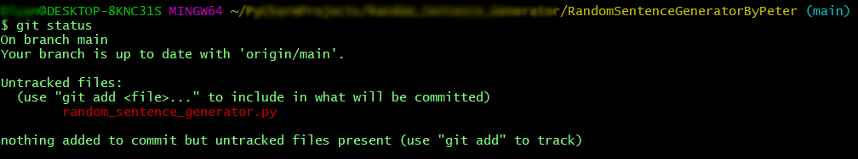

Now type:

|  |
| --- |
| git add . |

This command **adds** all modified files.

Next type:

|  |
| --- |
| git commit -m "Your message here" |

This command**commits** your changes. We also should **add** an appropriate **message**.

Second to the last type.

|  |
| --- |
| git pull |

This command **updates** your local **repository**.

Now the last thing that we should do is to **push** our changes by using the command:

|  |
| --- |
| git push |

This command **pushes** your changes to our local **repository**.

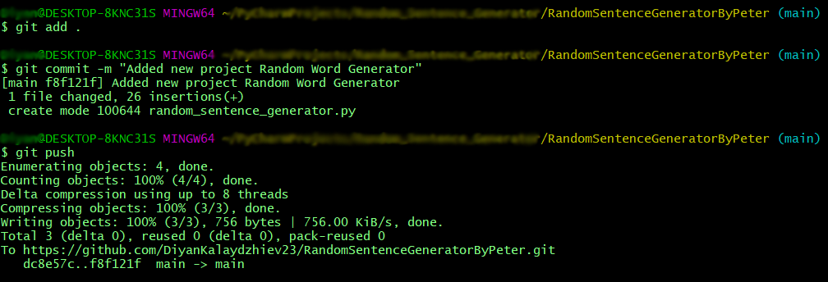

This is all you need to **update** your **repository** withGit Bash.

### Use GitHub Desktop (Option 2)

If you don't have GitHub Desktop on your computer, download and install it from here: <https://desktop.github.com/>

Go to **"File"** and chose **"Clone repository".**

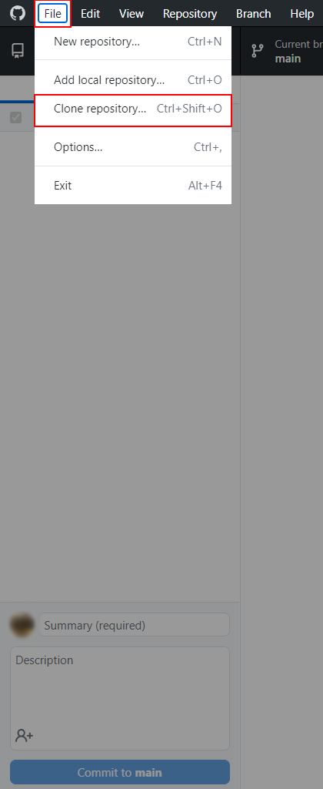

**Chose the repository** for the project, in our case "RandomWordsGeneratorByPetar" and hit the **"Clone"** button**.**

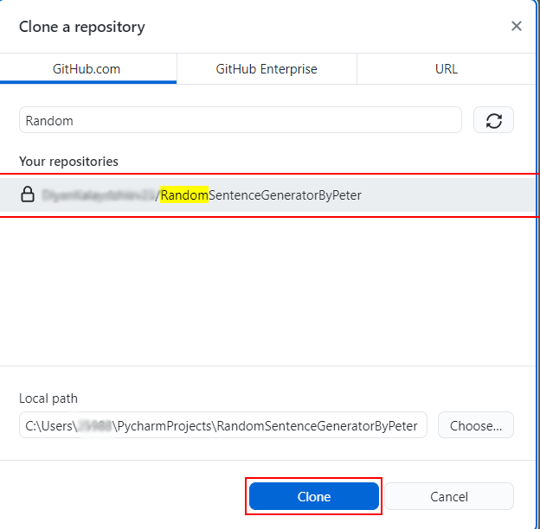

Your files from your GitHub repo will be downloaded to a **sub-folder** called as your project in GitHub, "**RandomSentencesGeneratorByPeter**" in our case.

The next thing to do is to add your project files to your cloned repository folder. It should look like this:



After that go to GitHub Desktop and **create a commit**, just like this. 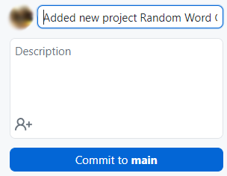

Then **push the commit** to the repository.

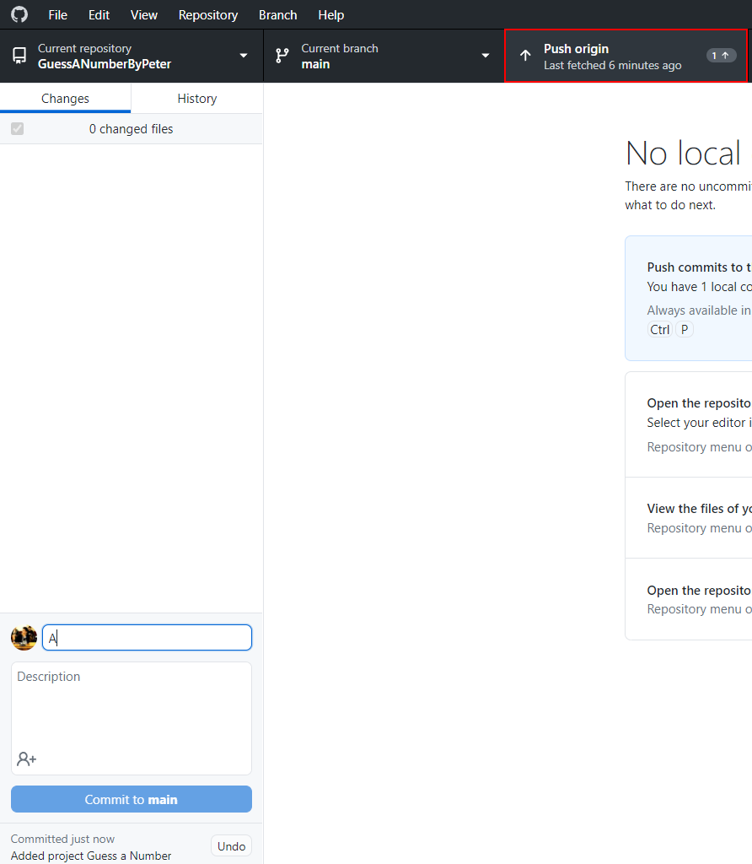

This is all you need to **update** your **repository** usingGit**Hub Desktop.**

## * Modify the Code, Write Your Own Features

Now, it's time to **play with the code** and **modify it**.

|  |  |
| --- | --- |
|  | This is your own project. **Be unique**. Don't be a copy/paster!   * Implement your **own features**. * **Implement the code yourself**, using your own coding style, code formatting, comments, etc. * Make the project **more interesting**. Learn by playing with the code and adding your own changes. |

Below are a few **ideas** of what you can implement or modify as an addition to your code.

### Add More Words

You can think of **more words to add** to make the sentences more interesting and fun.

### Try Different Sentence Structures

You can **change your sentence** and make it more complex:

* You can turn your **sentence to a question**: ["Who" question word/phrase] + [Verb] + [Subject] + [Main Verb] + [Object or Other Information].
* You can add more sentence parts in the right places or change the place of the current ones.
* You can think of more ways to change your sentence.

### Additional Ideas

* Consider a way to create a more **complex sentence generator**.
  + Example of a more complex generator: <http://lomacar.github.io/Random-Sentence-Generator>.
* You can add anything else in your code, based on your own ideas?

### Commit to GitHub

Now **commit and push your code changes** to your GitHub repo!

|  |  |
| --- | --- |
|  | It is very important to **commit frequently** your code to GitHub. This way you create a **rich commit history** for your project and your GitHub contribution graph is growing:  A picture containing chart  Description automatically generated |

## 5. Create a README.md File

It's highly recommended to provide documentation as part of your 'project on GitHub to describe what the project is doing. So, let's make one for this **project**. Let's start by editing the README.md file from our repo on GitHub:

Add a project name. Use "#" in front of the text to indicate the **title**:

You can **view** the current progress by pressing the [Preview] button:

### Documentation Sections

Add **information** about your project in your README.md file: project goals, technologies used, screenshots, live demo, etc. Typically, you should have the following **sections**:

* **Project title** (should answer the question "What's inside this project)
* **Project goals** (what problem we solve, e. g. we implement a certain game)
* **Solution** (should describe how we solve the problem 🡪 algorithms, technologies, libraries, frameworks, tools, etc.)
* **Source code link** (give a direct link to your source code)
* **Screenshots** (add screenshots from your project in different scenarios of its usage)
* **Live demo** (add a one-click live demo of your code)

### Use Markdown

Note that the GitHub README.md file is written in the **Markdown language**. Markdown combines text and special formatting tags to describe formatted text documents.

You can learn more about **Markdown** here: <https://docs.github.com/en/get-started/writing-on-github/getting-started-with-writing-and-formatting-on-github/basic-writing-and-formatting-syntax>.

### Project Goals

Start your documentation by describing your **project goals**. What problem does your project solve?

### Sample Documentation

This is an **example** of how you can document your project. Don't copy-paste it! 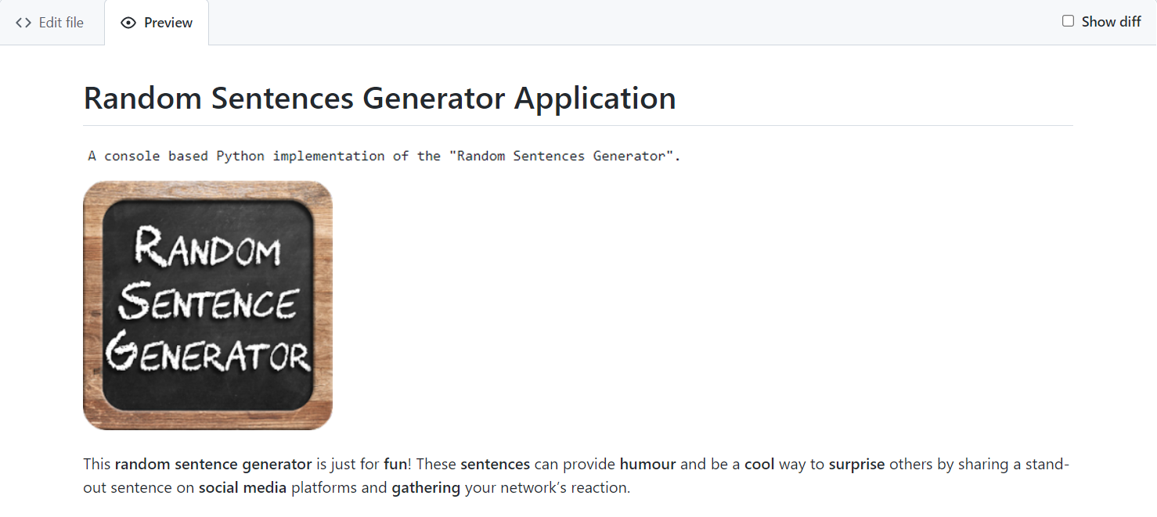

|  |  |
| --- | --- |
|  | **Write the project documentation yourself**. Don't copy/paste it!  This is your **unique GitHub profile** and your own unique project. **Be different** from others. |

Find an **appropriate** **image** and add it. You can add **images** as follows:



### Your Solution

Describe how you **solve the problem**: algorithms, technologies, libraries, frameworks, tools, etc:

You can use the [**backtick**](https://en.wikipedia.org/wiki/Backtick)(`) at the **start** and **end** of the **word** to make it **grey**:



You can also use the **double-asterisk** (**) at the **start** and **end** of the word to **bold** it:



### Link to the Source Code

Add a **link** to your **source code** as follows:

[Source Code](random_sentence_generator.py)

### Screenshots

Add **screenshots** of your project:

1. **Take a screenshot** with your favorite tool (e.g., Windows).
2. **Paste** the screenshot in the GitHub Markdown editor, using [Ctrl+V]:

Example screenshots for the "Random Sentences Generator" game:





## 6. Upload Your App to Replit

You already should have a **Replit** profile. Now let's add our **project** there so we can share it with our **friends** and add it to our **GitHub** profile. You already should know how to do that.

Open the **menu** in the upper **left corner**. Click "**Create**", then select the **language** in which your project is **written**, select a name, and **create** the project. Choose Python. 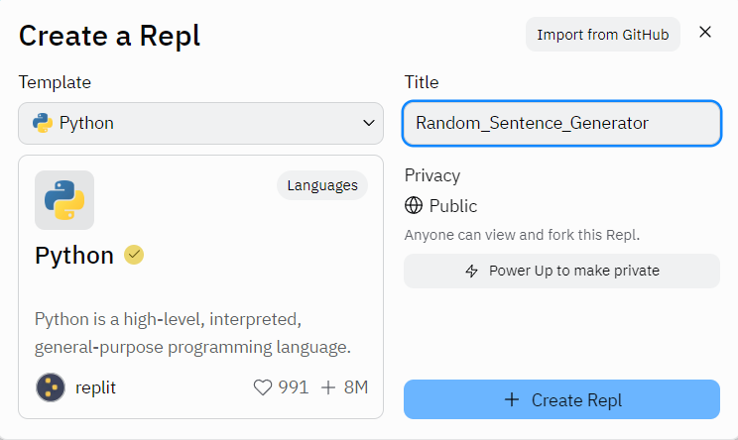

**Paste your code** in the "main.py" file:

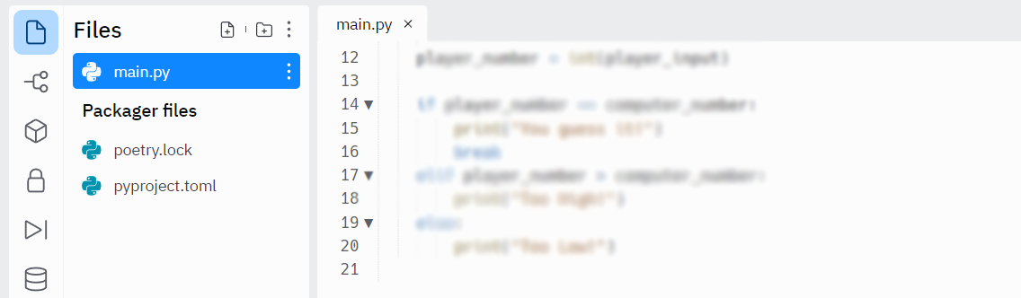

Click [Run] and enjoy your console application.

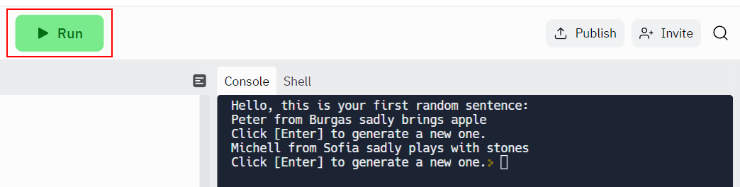

You can now **share** your app with your friends.

## 7. Add Replit Link to Your README.md

Now add a "**one-click live demo**" of your project from your **GitHub** project documentation. You can do it as follows:

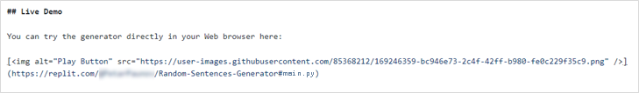

You can take a **screenshot** from Replit.com and **paste it** into the GitHub documentation editor directly with **[Ctrl+V]**.

Now we have completed our **Random Sentences Generator** and we have a new **project** in our GitHub portfolio.